**IS 340 Operating Systems**

**HOP07 – Installing Packages On Your Linux VM**

3/25/2021 Developed by Matt Raio

02/14/2022 Reviewed by Ken Ling

School of Technology & Computing (STC) @ City University of Seattle (CityU)

**Before You Start**

* Version numbers may not match with the most current version at the time of writing. If given the option to choose between stable release (long-term support) or most recent, please choose the stable release rather than beta-testing version.
* This tutorial targets new users with limited experience with Linux.
* There might be subtle discrepancies along the steps. Please use your best judgment while going through this cookbook style tutorial to complete each step.
* For your working directory, use your course number. This tutorial may use a different course number as an example.
* The directory path shown in screenshots may be different from yours.
* If you are not sure what to do or confused with any steps:
  1. Consult the resources listed below.
  2. If you cannot solve the problem after a few tries, ask a TA for help.

**Learning Outcomes**

Students will be able to:

* Install packages that extend the Linux OS to serve the needs of the student.

Prerequisite:

Please check your current system properties if running a Windows laptop/desktop.

Also, based on the previous HOP01, please be mindful of those resources taken for the virtual machine created.

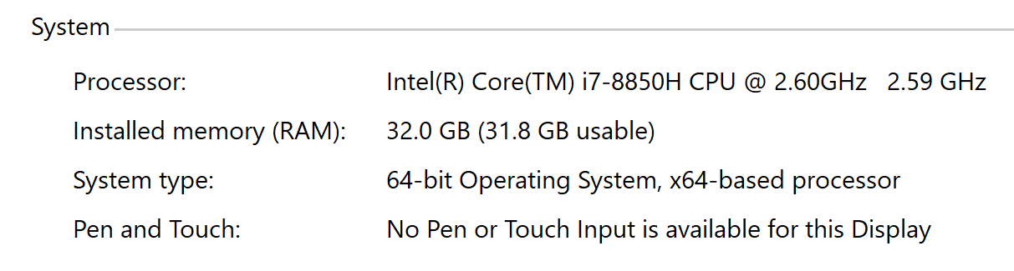

**Resources**

The first HOP for Module 1 and 2 in IS340 should be completed before attempting this lab.

**Purpose of this lab:** At this point, you have accomplished much in the sheer volume of HOPS and VL covered by the time you get to this HOP in week 7. Having said that, we can assume the following:

The student has completed to his or her ability all HOPS (1 – 6) and has documented this and uploaded it into BB for grading. It’s important since the student is being graded not necessarily for correctness of a given task, but that it was documented for completeness.

Identifying one’s weaknesses is critical in identifying those tasks that need to be worked on in your personal sandbox. The sandbox is a personal environment to try your hand at building an exact working model of whatever it is you wish to specialize in or support.

Consequently, the Linux virtual machine should be built and added to based on ***your*** academic and professional career. This machine will get built up, or torn down due to limitations of the HOST machine or quite frankly, the student may wish to go another route.

For example, you may take this course to get an understanding of the OS, but what is the application for you personally? Either a student follows the course of a developer, a network engineer or some combination of that as a DevOps engineer. With that, this particular module is basically the same with the exception that the student has the option to install a package he or she believes will be better suited for each individual goal.

Consequently, this HOP is about one of two options:

1.) Follow this tutorial to install PyCharm (a python IDE) on your linux vm.

2.) If you don’t want to use PyCharm, or you want to install a different package from the command line, then answer the following question:

Assignment Task #1: Are you going to follow the tutorial and install the recommended package? If not, what is the package you want to install? Write this in a document labeled HOP07.

**Section 1: Ways to install packages**

Generally speaking there are three primary ways to install packages.

* Use a package manager like the Advanced Package Tool (apt) from the command line.
* Use a graphical package manager like Synaptic Package Manager.
* Follow the instructions to install a compressed file and uncompress it and run the installer script.
* Build your own from source code.

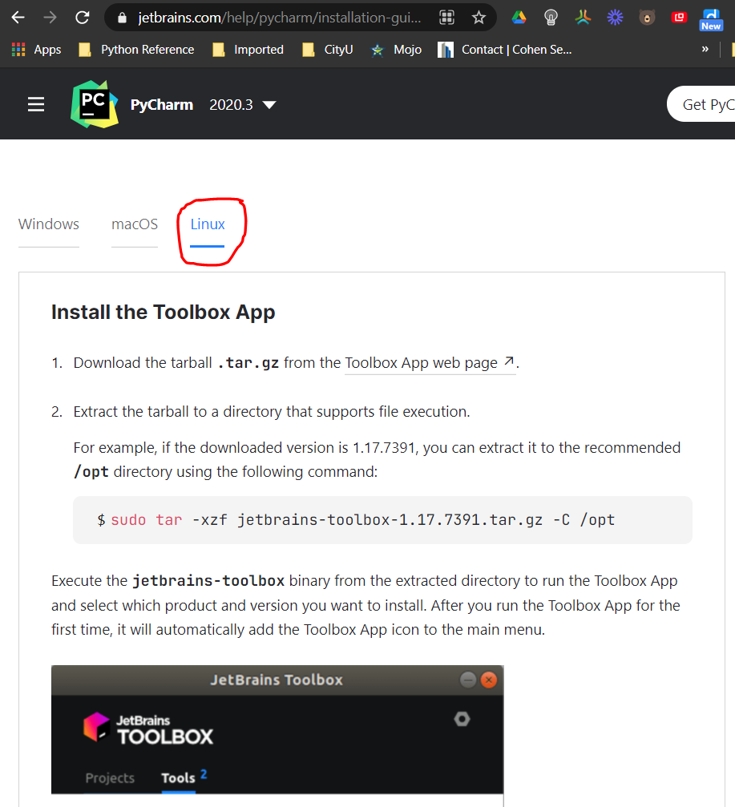Since this is an essentials course, we will focus only on the first two options. PyCharm has a way to install the package directly from the website because it calls a separate routine to install on your system. But generally, the preferred method is to get used to using the command line (apt) since there are many HOW-Tos on different websites that you can literally copy and paste the command into the terminal if the syntax is causing errors at time of execution.

**<------Click on the hyperlink “Toolbox App web page”**

**Section 2: Some HOW-TO guides are better than others…**

Go to this website to download the PyCharms compressed installer: <https://www.jetbrains.com/help/pycharm/installation-guide.html#toolbox>

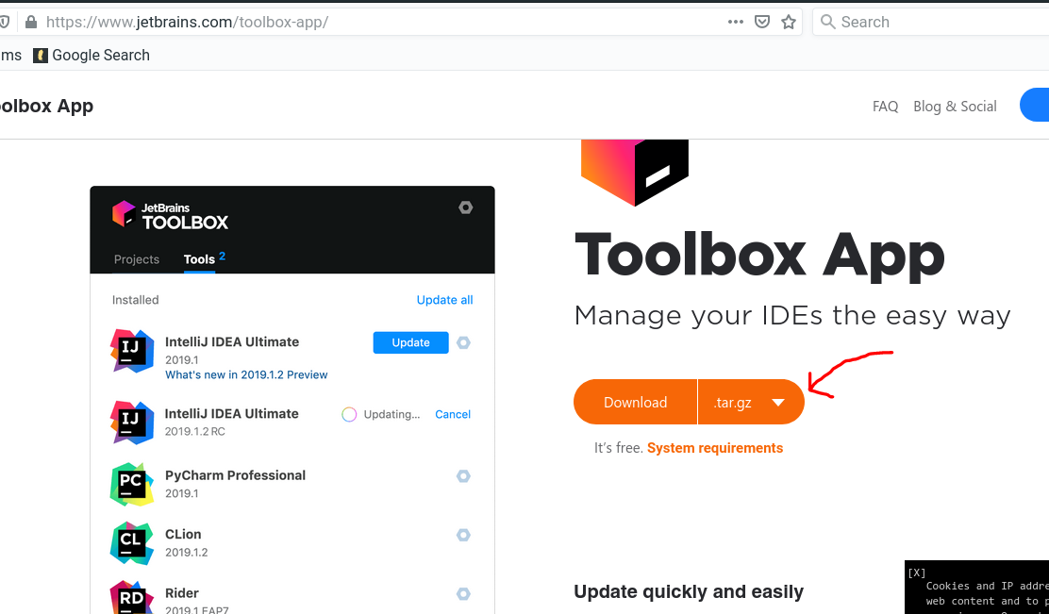There is a ‘Linux’ tab you need to click on.

Select ‘tar.gz’ Linux.

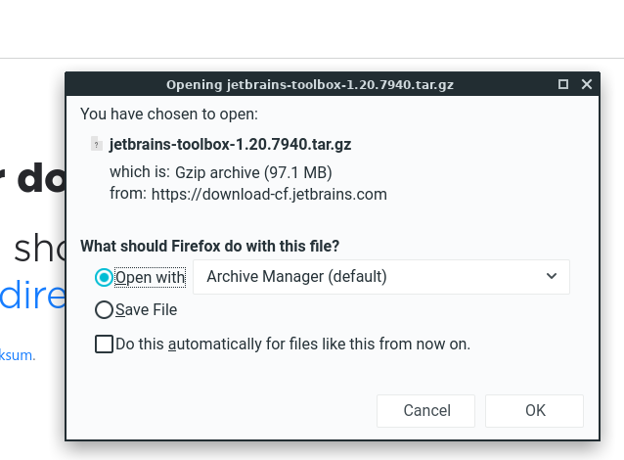**!**Depending on the version of Linux you installed, you might have an option to open the compressed file with ‘Archive Manager’ which LinuxLite has installed by default. Otherwise, you may need to just choose to ‘save the file’ and install a separate package to decompress the files. For this tutorial, we will use the Archive Manager.

With the Archive Manager open, click on the ‘Extract’ link in the top right corner of the window.

Click the path to Downloads

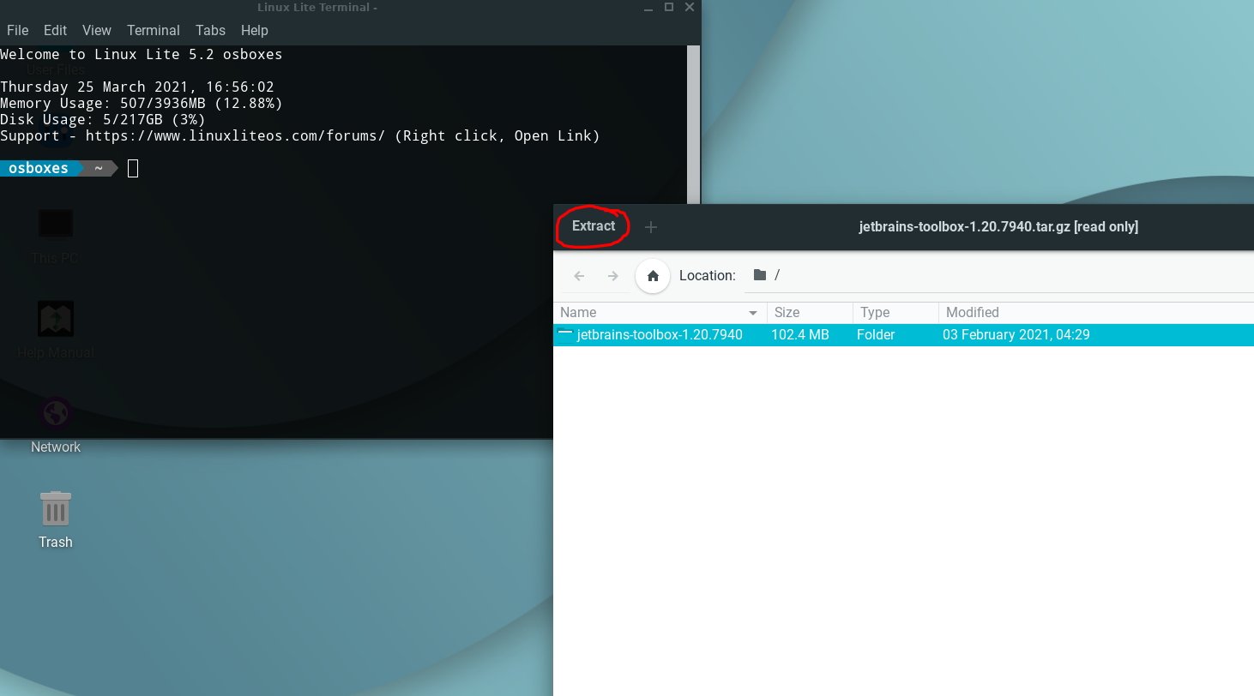

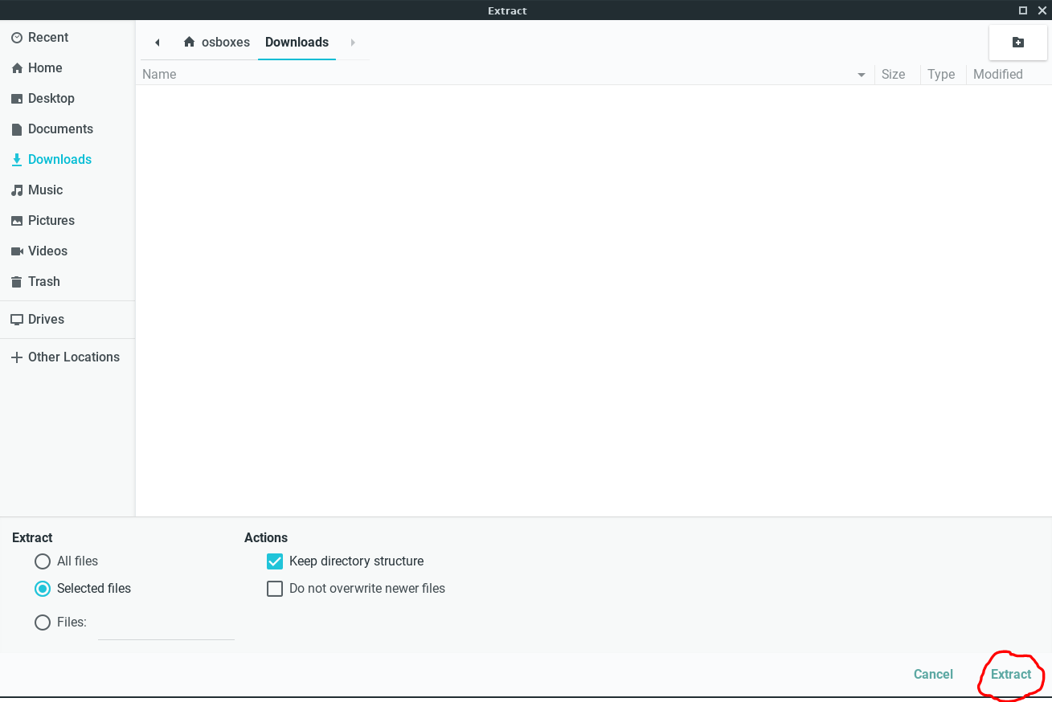

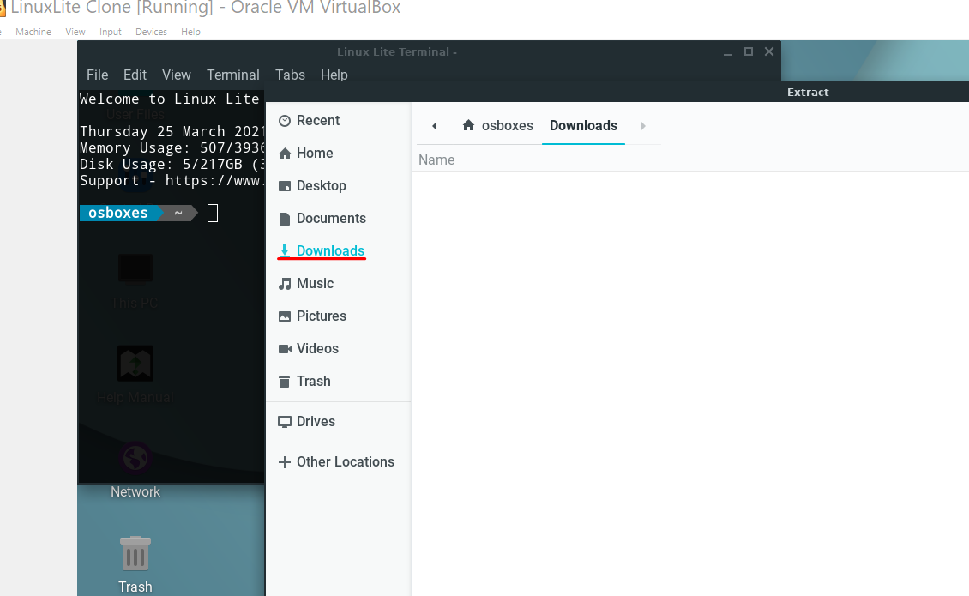

Now click “Extract”

You will now see the files extracted into the Download folder.

**!**If you are already knowlegable of the command line, you can alternatively use this tutorial here: https://shreya-singh.medium.com/how-to-install-pycharm-in-ubuntu-16-04-ubuntu-14-04-ubuntu-18-04-linux-easiest-way-5ae19d052693

The Archive Manager completes the task and prompts you to Show the files.

Click okay and the File Manager shows a new folder called “jetbrains-toolbox-1.20.7940”. Click on that folder. Your path should look similar to the following screenshot below:

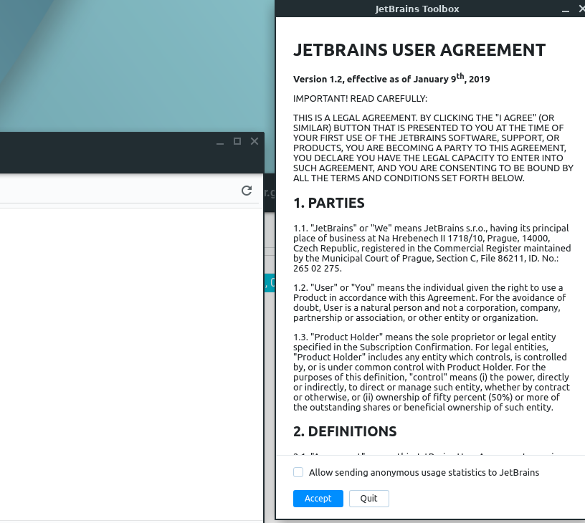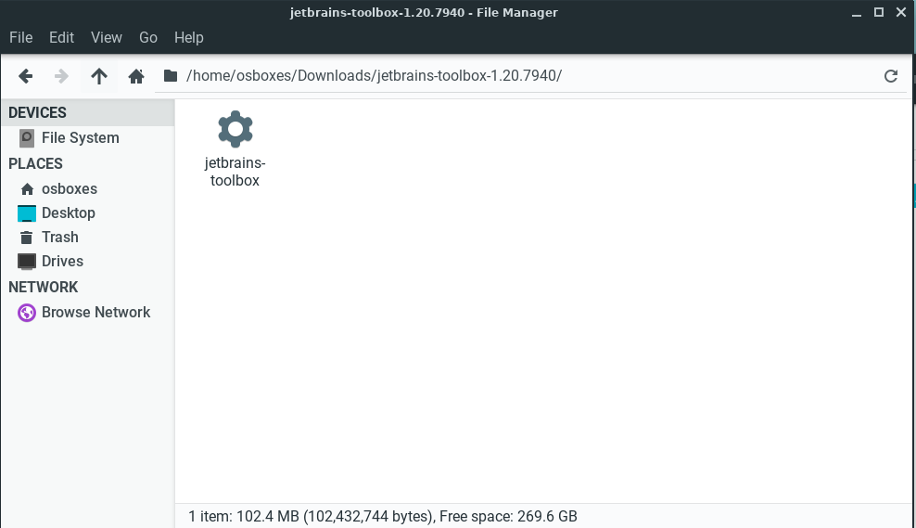You can double click on the gear icon, or right click on it and choose execute.

**!**A common issue for new users of linux is whether or not the current user is authorized to execute a script. This version of osboxes doesn’t have that issue and will launch the EULA from jetbrains. Other versions of linux may force you to enter a password if your account is able to elevate the execution of a script. If you have any issues with this reach out to the TA or myself with the subject line “Can’t launch jetbrains-toolbox Module 7 HOP”.

Choose whether or not to “Allow sending anonymous usage statistics to JetBrains” and click “Accept”.

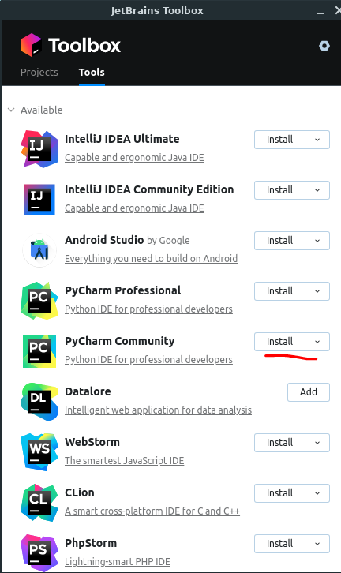You now have a choice of Jetbrains products to choose from. The PyCharm Community is free and if you have a student account with CityU, inquire of Jetbrains if you can get a ‘student’s license’ for free. For now, the Community version is acceptable.

The installer will now download all the files and execute the installation of PyCharm**.

A small popup window will confirm that PyCharm is installed. The toolbox will reflect that fact:

Launch Jetbrains from the search bar in LinuxLite

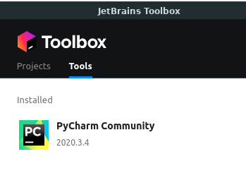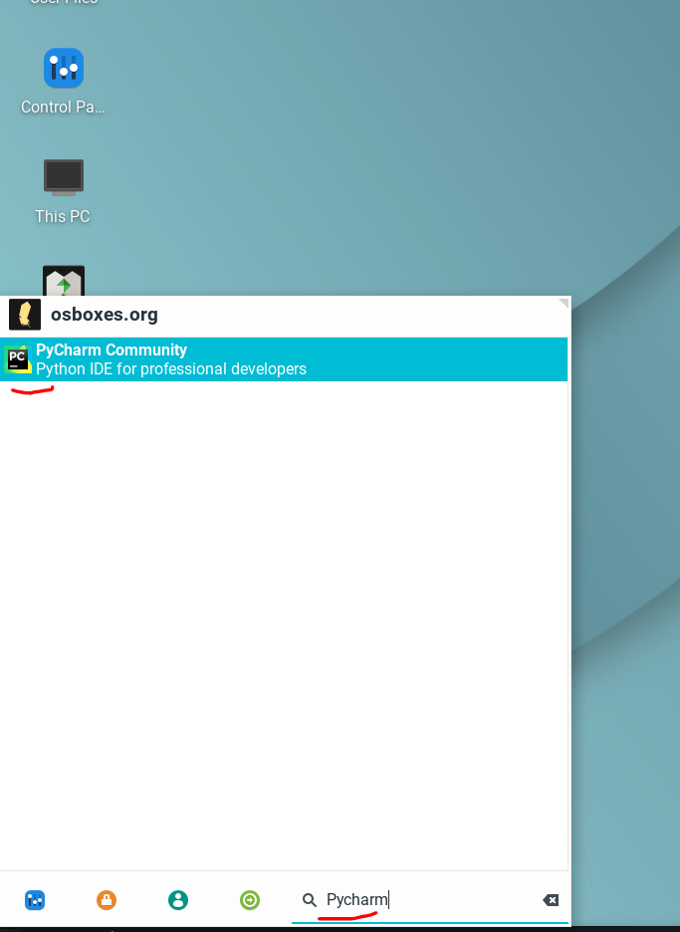At this point in the tutorial, the PyCharm IDE is successfully installed. Launching this will open your IDE to start coding in Python!

Assignment Task #2:Open Pycharm and complete the following option(s).

1.) Create a new text in Pycharm and tell me how this tutorial was. Make a screenshot and load it into HOP07 document.

2.) Create a new pycharm python project and create a new .py document. You can google a ‘hello world’ python script and screenshot that.

3.)For those that chose NOT to do this tutorial, screenshot what package you installed and why.

**Submit your Work to Brightspace**

Please upload all your files for this hands-on practice to the HOP assignment on Brightspace.